Arduino Opta

Introduction
Arduino Opta is Arduino's micro Programmable Logic Controller (PLC) for Industrial IoT applications, developed in partnership with Finder, a leading manufacturer of industrial and building automation devices. Built around the STM32H747XI dual-core Arm Cortex-M7 + Cortex-M4 microcontroller, Opta brings real-time control, monitoring, and predictive maintenance capabilities to a compact DIN-rail form factor. Because every Opta variant shares the same base I/O layout, snap-on expansion modules and wiring designed for one unit generally work across the whole family, which is one of the main reasons it has become a reference platform for professionals moving from prototyping to industrial deployment. Opta can be programmed with the familiar Arduino sketch language or with any of the five IEC-61131-3 PLC languages (Ladder Diagram, Structured Text, Function Block Diagram, Sequential Function Chart, and Instruction List) through the Arduino PLC IDE.
Arduino Opta Family
- Opta Lite - the base variant, with onboard Ethernet and a USB-C port for programming and power.
- Opta RS485 - same as the Lite, plus an RS-485 half-duplex interface for Modbus RTU and other serial fieldbus communication.
- Opta WiFi - the most versatile variant, adding Wi-Fi and Bluetooth Low Energy connectivity on top of Ethernet, USB-C, and RS-485.
- Opta Ext A0602 - Analog Expansion module that snaps onto any Opta base unit to add analog inputs, analog outputs, and PWM outputs.
- Opta Ext D1608E / D1608S - Digital Expansion modules that snap onto any Opta base unit to add digital inputs and additional relay outputs, available with electromechanical (D1608E) or solid-state (D1608S) relays.

Opta Lite
1. Features
- Entry-level Opta variant - Ethernet and USB-C only, no serial or wireless interfaces
- STM32H747XI dual-core Arm Cortex-M7 (480 MHz) + Cortex-M4 (240 MHz) microcontroller
- 8 configurable digital / analog (0-10 V) input channels
- 4 Normally Open relay outputs rated 250 VAC / 10 A
- Onboard ATECC608B secure element for encrypted, authenticated connections
- USB-C port for programming and data logging (not for powering the relay outputs)
- DIN-rail mountable, industrial temperature range
- Expansion port for up to 5 snap-on analog or digital expansion modules

2. Diagram

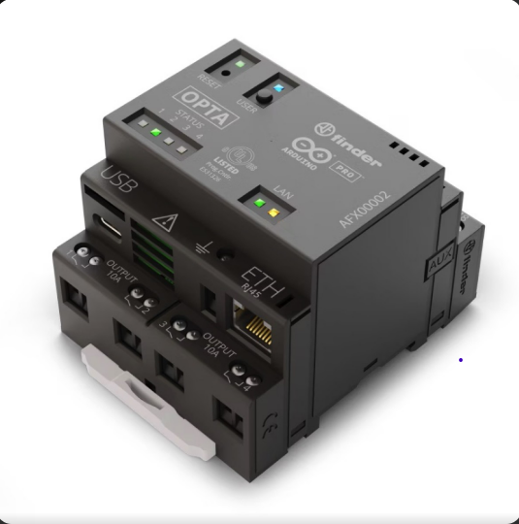
Arduino Opta Lite
3. Specifications
Specification | Value
Microcontroller | STM32H747XI (Arm Cortex-M7 @ 480 MHz + Cortex-M4 @ 240 MHz)
Operating Voltage / Supply | 12-24 V DC
Digital / Analog Inputs | 8 (configurable, 0-10 V range)
Relay Outputs | 4 x NO relay, 250 VAC / 10 A
Flash Memory | 2 MB internal + 16 MB external QSPI
RAM | 1 MB (programming)
Connectivity | 10/100 Ethernet (TCP/IP, Modbus TCP), USB-C
Security | ATECC608B secure element
IP Rating | IP20
Operating Temperature | -20 degC to +50 degC
Dimensions (W x L x H) | 69 x 90 x 75.4 mm (4 DIN modules)

4. Advantages
- Lowest-cost entry point into the Opta / micro-PLC ecosystem
- Simple to deploy where only Ethernet-based monitoring is required
- Fully compatible with all Opta digital and analog expansion modules
- Same programming experience (Arduino sketch or PLC IDE) as the rest of the family
- Compact DIN-rail form factor with no external cooling required
5. Disadvantages
- No RS-485 interface, so it cannot talk to Modbus RTU serial fieldbus devices directly
- No built-in wireless connectivity
- Only 4 relay outputs and 8 inputs on the base unit without expansions
- Relies on external power for the relay outputs; USB-C alone will not drive them
6. Applications
- Simple machine control over Ethernet / Modbus TCP
- Small automation cells that do not need serial fieldbus or wireless links
- Building automation nodes reporting to a local Ethernet network
- Cost-sensitive retrofits of existing relay panels
- Educational and prototyping PLC projects
Opta RS485
1. Features
- Same base hardware as Opta Lite, plus an onboard RS-485 half-duplex interface
- STM32H747XI dual-core Arm Cortex-M7 (480 MHz) + Cortex-M4 (240 MHz) microcontroller
- 8 configurable digital / analog (0-10 V) input channels
- 4 Normally Open relay outputs rated 250 VAC / 10 A
- RS-485 terminal connector for Modbus RTU or custom serial protocols
- Onboard ATECC608B secure element
- DIN-rail mountable, industrial temperature range
- Expansion port for up to 5 snap-on analog or digital expansion modules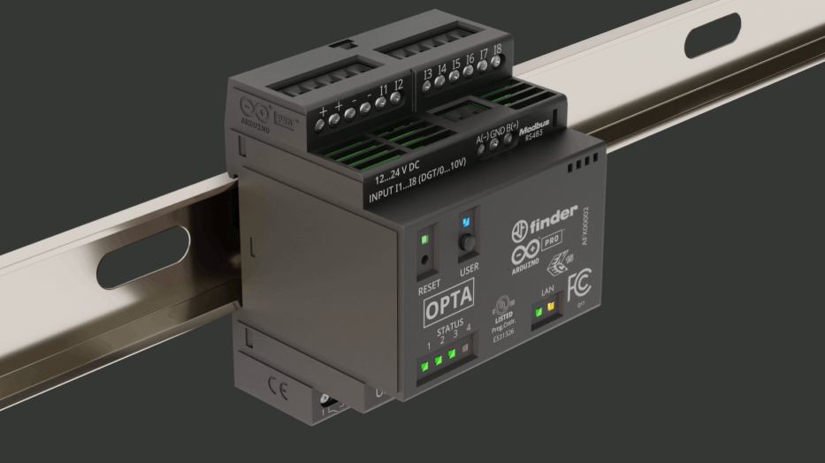
3. Specifications

Specification | Value
Microcontroller | STM32H747XI (Arm Cortex-M7 @ 480 MHz + Cortex-M4 @ 240 MHz)
Operating Voltage / Supply | 12-24 V DC
Digital / Analog Inputs | 8 (configurable, 0-10 V range)
Relay Outputs | 4 x NO relay, 250 VAC / 10 A
Flash Memory | 2 MB internal + 16 MB external QSPI
RAM | 1 MB (programming)
Connectivity | 10/100 Ethernet (TCP/IP, Modbus TCP), USB-C, RS-485 half duplex (Modbus RTU)
Security | ATECC608B secure element
IP Rating | IP20
Operating Temperature | -20 degC to +50 degC
Dimensions (W x L x H) | 69 x 90 x 75.4 mm (4 DIN modules)

4. Advantages
- Adds Modbus RTU / serial fieldbus integration without the cost of wireless radios
- Same footprint, I/O count, and programming model as Opta Lite
- Bridges legacy RS-485 sensors and drives to a modern Ethernet-connected PLC
- Fully compatible with all Opta digital and analog expansion modules
- Good middle ground for panels that need serial integration but not Wi-Fi/BLE
5. Disadvantages
- No built-in wireless connectivity
- Slightly higher cost than Opta Lite for the added RS-485 transceiver
- Only 4 relay outputs and 8 inputs on the base unit without expansions
- RS-485 wiring still needs to be laid out and terminated correctly on-site
6. Applications
- Interfacing with Modbus RTU sensors, drives, or energy meters
- Bridging legacy serial industrial equipment to Ethernet / Modbus TCP
- Building automation panels combining Ethernet and RS-485 devices
- Mixed brownfield / greenfield retrofits
- Any Opta Lite use case that later needs a serial fieldbus link

Opta WiFi
1. Features
- Most versatile Opta variant - Ethernet, USB-C, RS-485, Wi-Fi and Bluetooth Low Energy
- STM32H747XI dual-core Arm Cortex-M7 (480 MHz) + Cortex-M4 (240 MHz) microcontroller
- 2.4 GHz Wi-Fi (802.11 b/g/n) usable as Access Point, Station, or simultaneous AP/STA
- Bluetooth Low Energy (4.2 firmware / 5.1 hardware) for local commissioning and sensor pairing
- 8 configurable digital / analog (0-10 V) input channels
- 4 Normally Open relay outputs rated 250 VAC / 10 A
- Onboard ATECC608B secure element and X.509-compliant secure communication
- User LED and button dedicated to Wi-Fi/BLE status, present only on this variant
2. Diagram
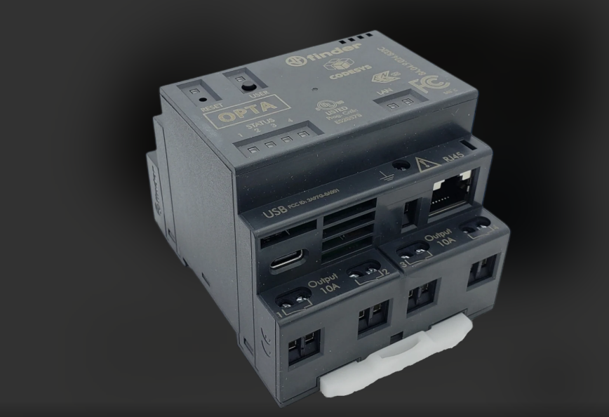
Arduino Opta WiFi
3. Specifications
Specification | Value
Microcontroller | STM32H747XI (Arm Cortex-M7 @ 480 MHz + Cortex-M4 @ 240 MHz)
Operating Voltage / Supply | 12-24 V DC
Digital / Analog Inputs | 8 (configurable, 0-10 V range)
Relay Outputs | 4 x NO relay, 250 VAC / 10 A
Flash Memory | 2 MB internal + 16 MB external QSPI
RAM | 1 MB (programming)
Connectivity | 10/100 Ethernet, USB-C, RS-485 half duplex, Wi-Fi 802.11 b/g/n, Bluetooth LE
Security | ATECC608B secure element
IP Rating | IP20
Operating Temperature | -20 degC to +50 degC
Dimensions (W x L x H) | 69 x 90 x 75.4 mm (4 DIN modules)

4. Advantages
- Only Opta variant with native Wi-Fi and Bluetooth Low Energy
- Simplifies remote monitoring via Arduino Cloud without extra wiring
- Bluetooth Low Energy enables local commissioning from a phone or tablet
- Keeps Ethernet and RS-485 as well, so no connectivity option is lost
- Same relay/input count and mechanical footprint as the rest of the family
5. Disadvantages
- Most expensive variant in the Opta family
- Wireless radios add some power draw compared to Opta Lite / RS485
- Wi-Fi performance depends on installation location inside metal enclosures
- Only 4 relay outputs and 8 inputs on the base unit without expansions
6. Applications
- IoT panels that send production or environmental data to the cloud
- Remote or hard-to-cable sites where running Ethernet is impractical
- Predictive maintenance dashboards using Arduino Cloud or third-party services
- Mobile commissioning and diagnostics via Bluetooth Low Energy
- Combined wired/wireless automation cells needing every connectivity option
Opta Analog Expansion A0602
1. Features
- Snap-on expansion module that adds analog I/O to any Opta base unit
- 6 programmable analog inputs: 4 for 0-10 V / 0-4-20 mA, 2 for 0-10 V / 0-4-20 mA or 3-wire RTD PT100
- 2 configurable analog outputs (0-10 V or 0/4-20 mA)
- 4 additional PWM outputs with user-defined output voltage (8-40 VDC via VPWM terminal)
- RTD channels support temperature measurement from -25 degC to +400 degC
- AUX ports on left and right for daisy-chaining with the Opta base unit or other expansions
- Up to 5 snap-on expansion modules supported per Opta base unit
- DIN-rail mountable, industrial temperature range
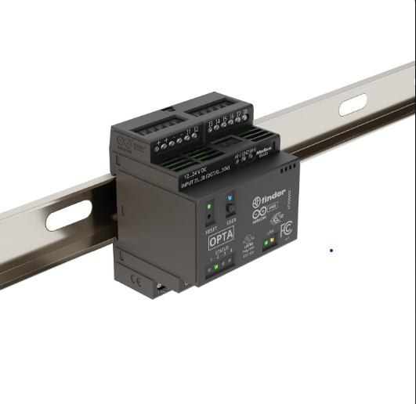
Arduino Opta Analog Expansion A0602
3. Specifications

Specification | Value
Analog Inputs | 6 (4x 0-10 V / 0-4-20 mA; 2x 0-10 V / 0-4-20 mA or 3-wire RTD PT100)
Analog Input Resolution | 12-bit
Analog Outputs | 2 (0-10 V or 0/4-20 mA)
Analog Output Resolution | 12-bit
PWM Outputs | 4, output voltage configurable 8-40 VDC via VPWM
RTD Temperature Range | -25 degC to +400 degC (PT100, 3-wire)
Supply Voltage | 12-24 V DC (via dedicated pins)
Expandability | AUX port left/right; up to 5 modules in daisy chain
IP Rating | IP20
Operating Temperature | -20 degC to +50 degC
Programming | From the connected Opta base unit only (no standalone MCU)

4. Advantages
- Adds real analog sensing and actuation without a separate analog PLC card
- RTD-capable channels remove the need for a separate temperature transmitter
- Flexible voltage/current selection per channel suits many industrial sensor types
- Shares programming environment with the Opta base unit (Arduino sketch or PLC IDE)
- Snap-on mechanical design keeps panel wiring compact
5. Disadvantages
- Requires a compatible Opta base unit; cannot operate standalone
- Adds to overall DIN-rail width and system cost per panel
- 12-bit resolution is adequate for most industrial use but not for high-precision metrology
- PWM output voltage is shared across all 4 channels via a single VPWM terminal
6. Applications
- Reading voltage or current analog sensors (pressure, level, flow transmitters)
- Acquiring PT100 temperature values in process or HVAC control
- Driving analog actuators such as proportional valves
- Dimming or speed control via the PWM outputs
- Water treatment and chemical process monitoring requiring precise analog control
Opta Digital Expansion D1608E
1. Features
- Snap-on expansion module that adds digital I/O with electromechanical relays

- 16 programmable digital inputs, compatible with 0-10 V and 0-24 V sensors

- 8 additional Normally Open electromechanical relay outputs, 250 VAC / 6 A

- 14-bit ADC resolution when inputs are read in the 0-24 VDC range

- AUX ports on left and right for daisy-chaining with the Opta base unit or other expansions

- Designed in partnership with Finder, using the same relay technology as the Opta base unit

- Up to 5 snap-on expansion modules supported per Opta base unit

- DIN-rail mountable, industrial temperature range
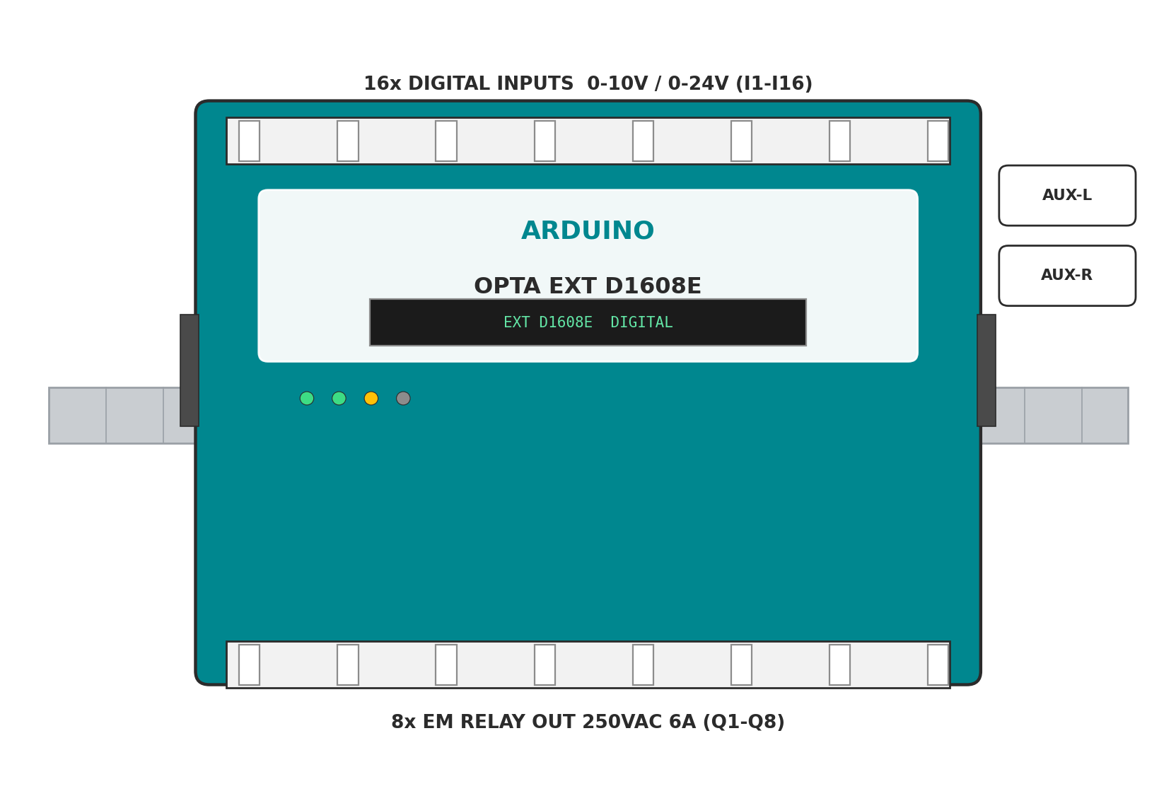

Arduino Opta Digital Expansion D1608E
3. Specifications
Specification | Value
Digital Inputs | 16, compatible with 0-10 V and 0-24 V sensors
Input ADC Resolution | 14-bit (0-24 VDC range)
Voltage Input Low (VIL) Max | 4 VDC
Voltage Input High (VIH) Min | 5.9 VDC
Relay Outputs | 8 x NO electromechanical relay, 250 VAC / 6 A
Expandability | AUX port left/right; up to 5 modules in daisy chain
IP Rating | IP20
Operating Temperature | -20 degC to +50 degC
Programming | From the connected Opta base unit only (no standalone MCU)
SKU | AFX00005

4. Advantages
- Electromechanical relays handle higher switching voltage and inrush current
- Doubles the digital sensor input count available to the system
- Familiar relay behaviour for engineers migrating from traditional PLC panels
- Shares programming environment with the Opta base unit (Arduino sketch or PLC IDE)
- Snap-on mechanical design keeps panel wiring compact
5. Disadvantages
- Requires a compatible Opta base unit; cannot operate standalone
- Electromechanical relays have a finite mechanical switching life versus solid-state
- Slower switching response than the solid-state D1608S variant
- Adds to overall DIN-rail width and system cost per panel
6. Applications
- Expanding digital sensor input count for large sorting or conveyor systems
- Switching motors, contactors, or lighting loads at mains voltage
- Retrofitting relay-based control panels with modern Arduino programming
- Building automation panels needing many independent on/off outputs
- Applications where relay contact isolation is preferred over solid-state switching
Opta Digital Expansion D1608S
1. Features
- Snap-on expansion module that adds digital I/O with solid-state relays
- 16 programmable digital inputs, compatible with 0-10 V and 0-24 V sensors
- 8 additional solid-state relay outputs, 24 VDC / 2 A, for fast, silent actuation
- 14-bit ADC resolution when inputs are read in the 0-24 VDC range
- AUX ports on left and right for daisy-chaining with the Opta base unit or other expansions
- Designed in partnership with Finder, using the same relay technology as the Opta base unit
- Up to 5 snap-on expansion modules supported per Opta base unit
- DIN-rail mountable, industrial temperature range
3. Specifications
Specification | Value
Digital Inputs | 16, compatible with 0-10 V and 0-24 V sensors
Input ADC Resolution | 14-bit (0-24 VDC range)
Voltage Input Low (VIL) Max | 4 VDC
Voltage Input High (VIH) Min | 5.9 VDC
Relay Outputs | 8 x solid-state relay, 24 VDC / 2 A
Expandability | AUX port left/right; up to 5 modules in daisy chain
IP Rating | IP20
Operating Temperature | -20 degC to +50 degC
Programming | From the connected Opta base unit only (no standalone MCU)
SKU | AFX00006

4. Advantages
- Solid-state relays switch faster and silently, with no moving contacts to wear out
- Well suited to high-cycle-count applications such as packaging or bottling lines
- Doubles the digital sensor input count available to the system
- Shares programming environment with the Opta base unit (Arduino sketch or PLC IDE)
- Snap-on mechanical design keeps panel wiring compact
5. Disadvantages
- Lower voltage/current rating (24 VDC / 2 A) than the electromechanical D1608E
- Requires a compatible Opta base unit; cannot operate standalone
- Solid-state outputs can be more sensitive to voltage transients than relays
- Adds to overall DIN-rail width and system cost per panel
6. Applications
- High-frequency switching in packaging, bottling, or palletizing systems
- Driving 24 VDC actuators, solenoids, or indicator loads
- Expanding digital sensor input count for large sorting or conveyor systems
- Applications where fast, silent, low-EMI switching is preferred over relays
- Building automation panels needing many independent low-voltage outputs
Comparison Summary
Module | Key Differentiator
Opta Lite | Ethernet + USB-C only, no RS-485 or wireless
Opta RS485 | Ethernet + USB-C + RS-485 (Modbus RTU)
Opta WiFi | Ethernet + USB-C + RS-485 + Wi-Fi + Bluetooth LE
Opta Ext A0602 | 6 analog in / 2 analog out / 4 PWM out expansion
Opta Ext D1608E | 16 digital in / 8 electromechanical relay out expansion
Opta Ext D1608S | 16 digital in / 8 solid-state relay out expansion

Connection to Your PoC
For a project that only needs Ethernet-based monitoring and relay switching, the Opta Lite is enough and keeps cost low. If the project needs to integrate existing Modbus RTU sensors or drives over a serial bus, the Opta RS485 is the better fit. If the final proof of concept needs to reach a phone, app, or the cloud without running network cable to the panel, the Opta WiFi should be used instead, since it is the only variant with built-in Wi-Fi and Bluetooth Low Energy. Once the base unit is chosen, the Opta Ext A0602 can be snapped on wherever analog sensors or proportional actuators are involved, while the Opta Ext D1608E or D1608S can be added whenever more digital inputs or relay outputs are needed - the electromechanical D1608E for higher-power mains switching, and the solid-state D1608S where fast, silent, high-cycle-count switching is preferred.

